Rotary is in the Family Blood.
It seems that Rotary does get into the blood of family members. PP Napa of the Rotary Club of Royal Hua Hin Niece Naratchaorn (Meen) Keawtem has been associated with Rotary for many years. When she was in High school Naratchaorn was President of Interact and attended RYLA in Chiang Mai that year.
Naratchaorn became a Rotaractor when she was studying at the Naresuan University in the Phitsanulok province.
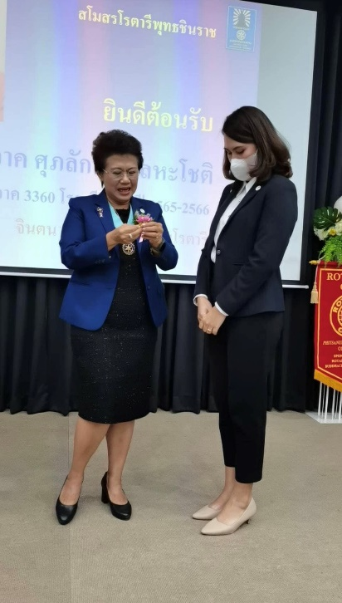
After completing her master’s degree, she joined the Rotary Club of Bhuddachinaraj in the province of Phitsanulok, Rotary District 3360.
Recently the District held an Intercity meeting in Chien Kon which was about a summary of the clubs in the district 3360 achievements, and the save lives save roads campaign as the President of the Rotary Club of Bhuddachinaraj is leading on this project.
It is important that the future of Rotary lies with the younger generation in countries around the world. The links between Interact, Rotaract and Rotary are becoming closer. These are our next leaders.

So, what are Interact Clubs?

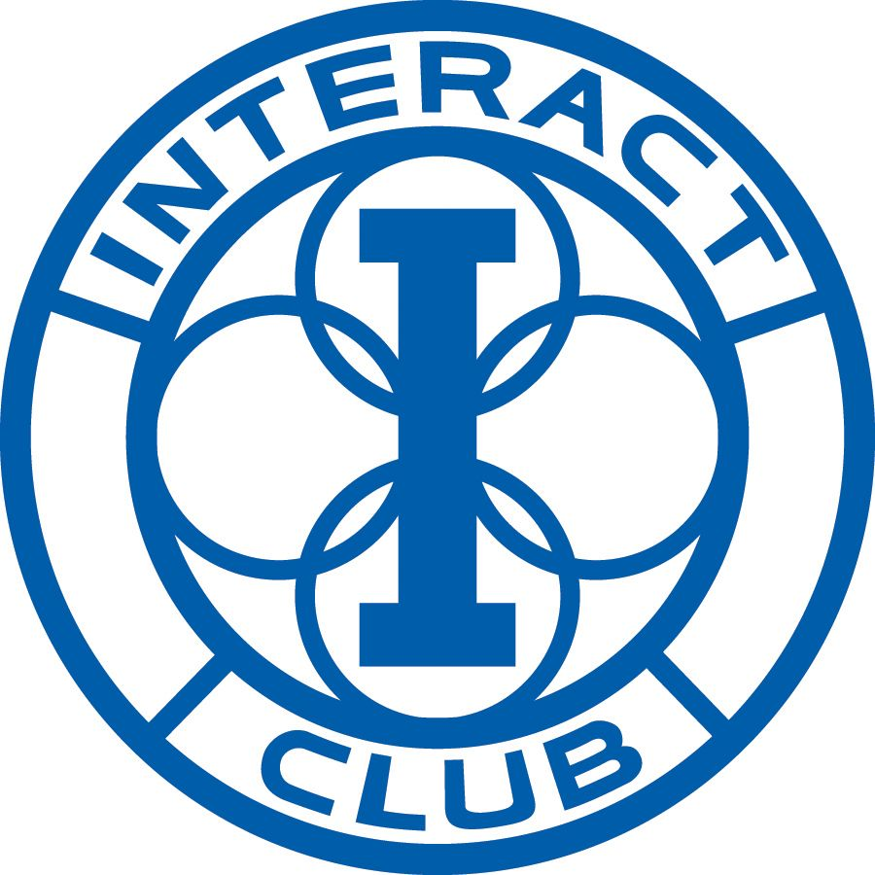
Interact clubs are formed to take action, build international understanding, and make new friends around the world.

Interact clubs bring together young people who are aged between 12 and 18 years old to develop their leadership skills whilst discovering the powers of service above self, in addition they can discover how leadership can be seriously fun.

Interact clubs are required to organise at least two projects every year, one that helps their schools or community and one that will promote international understanding. Rotary club sponsors mentor and guide interactors as they carry out projects and develop their leadership skills.

The benefits of joining an Interact Club are that it enables young people to connect with leaders in their communities and around the world to:

Take positive action to make a difference in their school and community

Discover new cultures and promote international understanding

Become a leader in your school or community

Have fun and make new friends around the world
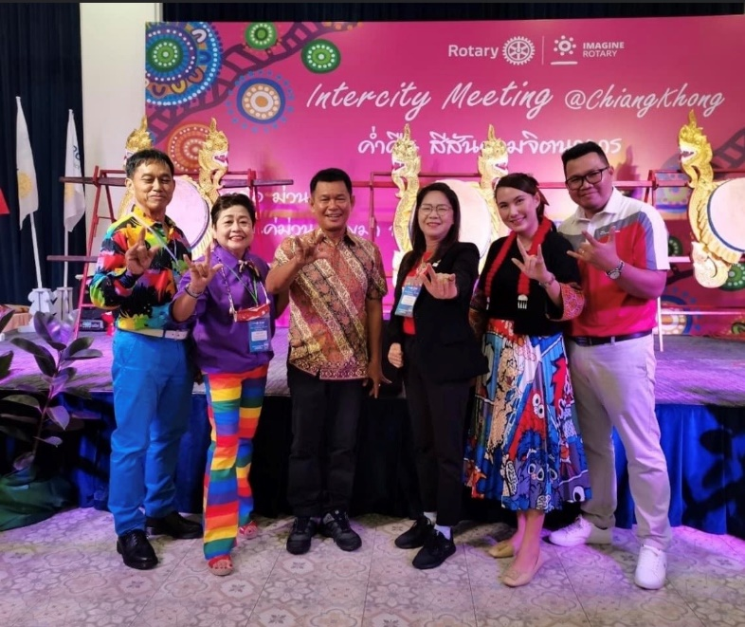
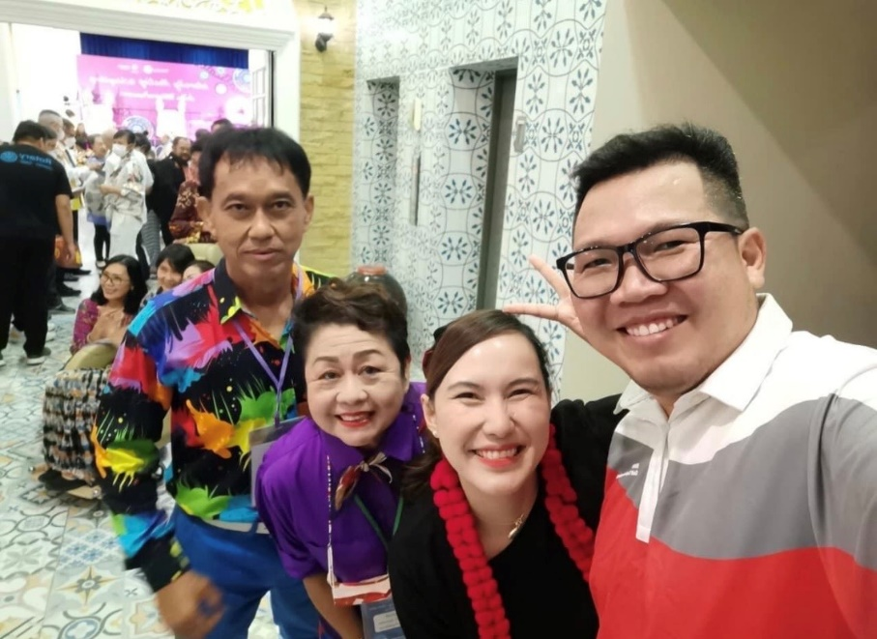

Congratulations to PP Napa of the Rotary Club of Royal Hua Hin for being a role model in her family and for Rotary.

