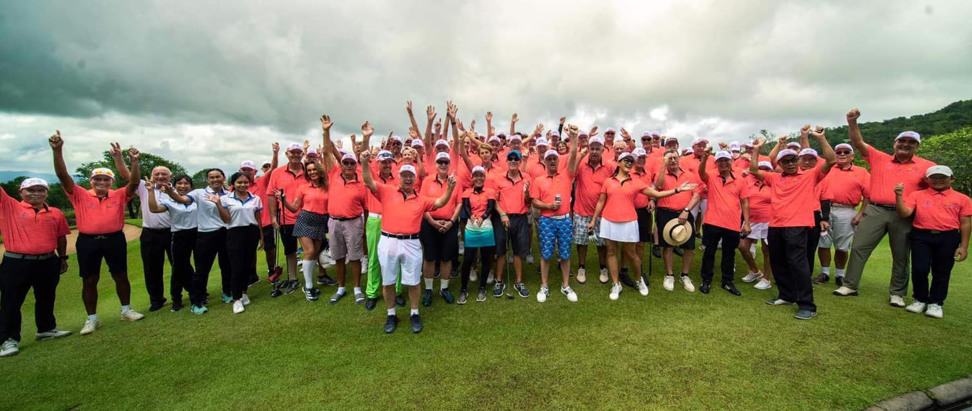
Rotary Club of Royal Hua Hin 12th Amateur Golf Classic.
The Rotary Club of Royal Hua Hin held their 12th Annual Amateur Golf Tournament at Banyan Golf Club on Friday 25th November, after postponing the tournament in 2021.
Despite the heavy rain on the day before and the morning of the tournament the prayers of everyone were answered with the rain stopping for the duration of Friday afternoon.
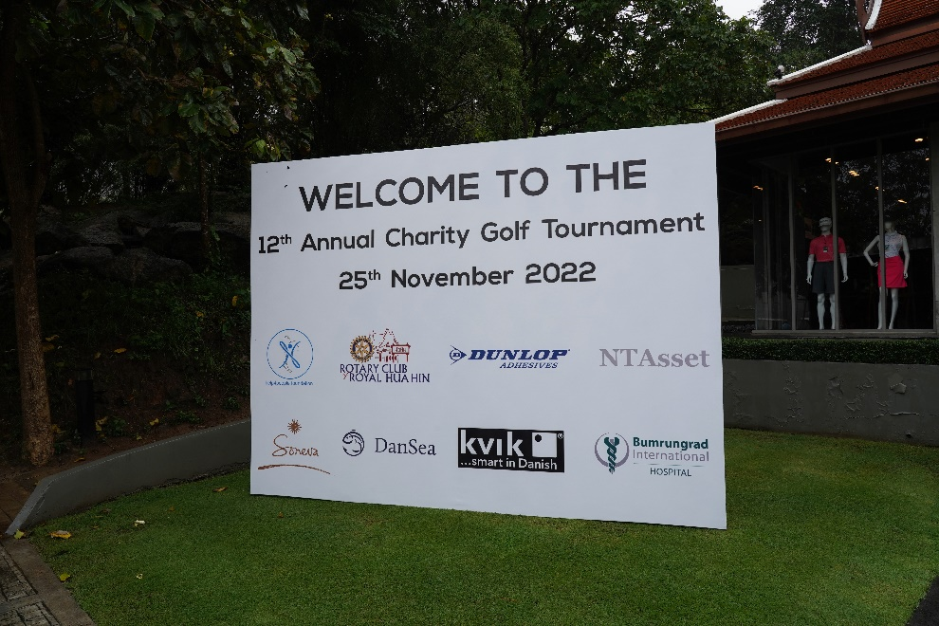
25 teams took part on the day, with players from around the globe, with some making the journey just to play in the tournament.
Despite the rain, the condition of the course was good so a big thanks to Simon and his team from Banyan, for helping to make the day run smoothly
We would also like to thank all our sponsors for helping us to raise what we hope will be just over 1 million Thai Baht, that will go towards our local projects supporting the communities of Hua Hin.
We are still working on the final outcome.

A first for a number of years was a Hole in One from Martin Bruch from the team Just for Fun on the signature par 3 15th Hole.
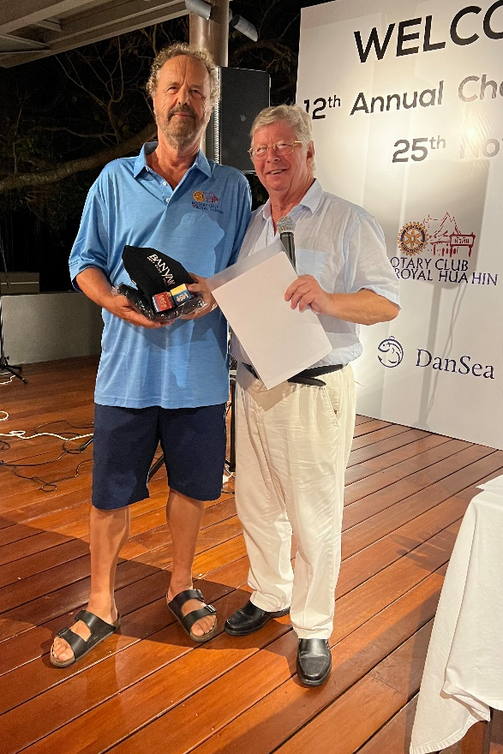

The winners on the day were as follows:
2022 winners The Rascals
Best Gross score KVIK
1st runner up HindiSwiss
2nd Runners up DanSea
A final thanks to the golf committee from the Rotary Club of Royal Hua Hin, chaired by Vice President Michel Zuber and all the volunteers that made the day such a success.
